**What is Version Control System?**

* A **Version Control System (VCS)** is a tool that helps track and manage changes to a project's codebase over time.
* It allows**multiple developers** to work on the same project simultaneously without conflicts, maintains a history of all changes, and enables easy rollback to previous versions if needed.
* VCS ensures **collaboration**, **code integrity**, and efficient management of **software development**.

**Why is the Version Control system so Important?**

* Version Control Systems (VCS) help track code changes, making it easy to revert to earlier versions.
* They support team collaboration by preventing code overwrites, maintain a history of who made changes and why.
* Version control systems offer a way to back up your project. If something goes wrong, you can always recover previous versions.
* You can create branches for different features or bug fixes, allowing multiple developers to work simultaneously without interfering with each other’s code. Once the work is done, branches can be merged back into the main project seamlessly.

**Types of Version Control Systems**

**1. Centralized Version Control Systems**

* Centralized Version Control Systems store the entire codebase and version history on a single central server.
* Developers must connect to the central server to perform operations like committing code, updating changes, or viewing history.
* It is easier to manage access control and maintain a single source of truth since everything is centralized.
* Collaboration is streamlined as everyone works on the same repository, reducing confusion over different versions.
* The system depends heavily on the central server; if the server goes down, no one can collaborate or access version history.
* Users need a network connection to commit or update code, limiting offline work capabilities.
* Common examples of CVCS include Subversion (SVN), CVS, and Perforce.

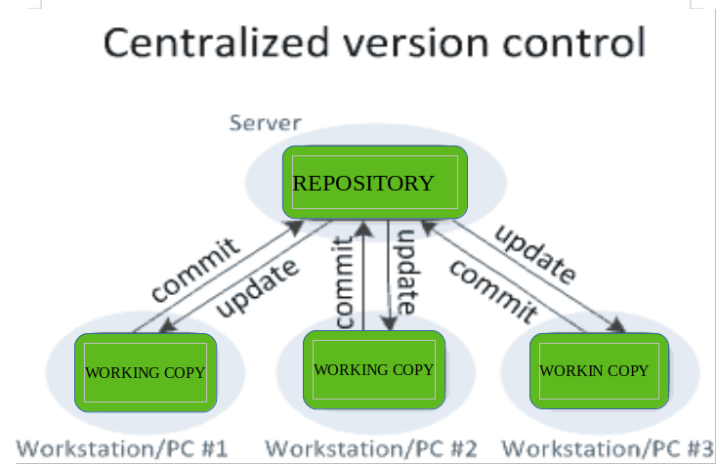

**Advantages of CVCS**

* Simplicity in setup and management.
* Easy to maintain a single central repository.
* Suitable for small teams or projects with limited collaboration needs.

**Disadvantages of CVCS**

* If the central server goes down, no one can commit or retrieve updates.
* Limited support for branching and merging compared to DVCS.
* It can become a bottleneck if many developers are committing at once

**2. Distributed Version Control Systems**

* Distributed Version Control Systems (DVCS) contain multiple repositories—each user has their own local repository and working copy.
* Committing changes only updates the user's local repository; others cannot see those changes until they are pushed to a shared (remote) repository.
* To make changes visible to others, the developer must push the committed changes to the central or remote repository.
* Similarly, pulling is required to update your local repository with changes made by others.
* Since each copy is a full backup, the system is more resilient to data loss or server failure.
* Collaboration is flexible, allowing developers to work independently on branches and merge changes when ready.
* It supports powerful branching and merging features, making it ideal for teams working on multiple features simultaneously.
* DVCS enhances speed and performance, as many operations (like commit, diff, or log) happen locally without server access.
* Popular examples of DVCS include Git, Mercurial, and Bazaar.

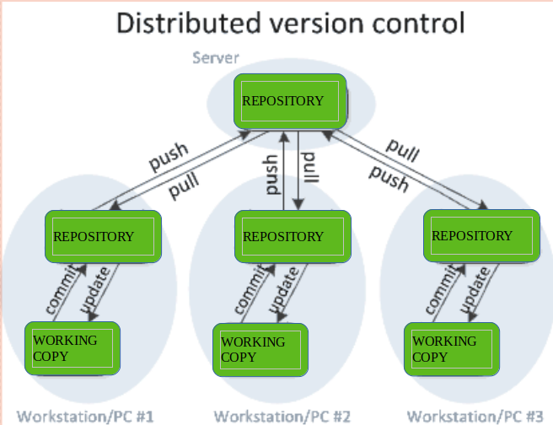

**Advantages of DVCS**

* Allows developers to work offline and commit changes locally before syncing with others.
* Better handling of branches and merges.
* Faster access to version history, as developers don’t have to rely on a central server.
* More resilient; if one copy of the repository is lost, it can be recovered from others.

**Disadvantages of DVCS**

* More complex setup and configuration.
* Can require more storage space as each developer has a full repository.
* Potentially higher bandwidth usage when pushing and pulling from central servers.

**Popular Version Control Systems**

**1. Git**

[Git](https://www.geeksforgeeks.org/git-tutorial/)is the most widely used Distributed Version Control System, developed by Linus Torvalds in 2005 for managing the Linux kernel. It is highly efficient, supports branching and merging, and has a fast, decentralized workflow. Git is the backbone of services like GitHub, GitLab, and Bitbucket, making it a popular choice for developers worldwide.

**Key Features of Git**

* Lightweight, fast, and efficient.
* Branching and merging are simple and non-destructive.
* Provides powerful commands like git clone, git pull, and git push.

**2. Subversion (SVN)**

Subversion is a popular centralized version control system. While not as commonly used in open-source projects today, SVN is still used by many organizations and enterprises for its simplicity and centralized nature.

**Key Features of SVN**

* Single central repository.
* Supports branching and tagging but is less flexible than Git.
* Versioning of files and directories.

**3. Mercurial**

Mercurial is another distributed version control system similar to Git but with a simpler interface. It is well-suited for both small and large projects and is used by companies like Facebook and Mozilla.

**Key Features of Mercurial**

* Simple, fast, and scalable.
* Supports branching and merging.
* Includes tools for managing project history and changes.